WARNING: DEFAULT NOTICE - OPPORTUNITY TO REMEDY RE:
CAUTION - Unlawful Breach of the People's Peace.
CEASE your claimed enforcement rights, and DESIST until this dispute is settled.
Notice to principal is notice to agent, notice to agent is notice to principal

- This day day of month in the year 20 21,

- Under both our inalienable natural rights, our equitable rights, which prevail in the event of a conflict with the common law, legislatively codified in §49 of the Senior Courts Act 1981, and, our common law rights and powers, including arrest, legislatively codified in Part 1, §2 of the Criminal Law Act 1967, and §24A of the Police and criminal Evidence Act 1984;

- I, being innocent until proven guilty, NOTICE SERVER'S name ;
  - Contactable at: NOTICE SERVER'S email address ;

- do serve you: NOTICE RECEIVER'S name, if more then list in Schedule 1;
  - Contactable at: NOTICE RECEIVER'S email address, if more then list in Schedule 1;
  - this WARNING

- You failed to provide reasonable evidence at the time to breach the people’s peace as you are lawfully obliged under the binding precedence of the dispute between the Commissioner of Police of the Metropolis v Raissi: CA [2009] QB 564, [2008] EWCA Civ 1237, which further affirms
'...following orders is no excuse...'

- You failed to show reasonable cause for your claimed right that another is under a lawful obligation to perform at your command, relating to:
detail the command they are asking you to perform

  - Your actions included; threatening and intimidating behaviour, designed to generate fear and public alarm, including discrimination and the suppression of the freedom of speech granted to all the people upon acceptance of the crown in the Bill of Rights 1688.

  - Thereby giving me reason to believe your intent is to provoke a breach of the peace.

- As claimant of the rights, I put you to strict proof that your actions are lawful by:

  - Passing the 3 tests of lawful, requiring you to rationally show the causal relationship of your chosen actions are:
    - based upon both the cause and solution being possible (legitimate cause and aim), and

    - rational, detailing with supporting evidence, showing the balance of probabilities upon which a civil jury determines the facts, including for other available options, and

    - showing your chosen actions are proportionate and reasonable to show your chosen action is the least intrusive alternative to deal with the claimed cause, and

  - Thereafter, your claim must meet The 3 tests to lawfully breach another's peace:

    - Has anyone been harmed (NO VICTIM = NO HARM), OR

    - Does someone intend to cause harm, to a person, or to his/her property, by putting such a person in fear of such harm, through an assault, affray, a riot, unlawful assembly or another disturbance, OR

    - Has someone breached duties arising out of lawful contract, which has created respective rights and obligation (also an obligation for a PUBLIC BODY at 1.1, as affirmed by The Master of the Rolls in the Pre-Action Protocol for debt claims available at https://www.justice.gov.uk/courts/procedure-rules/civil/pdf/protocols/debt-pap.pdf.

- The lawful basis of my reasonable grounds of your breach of the people's peace is further supported in Schedule 2 below, summarised as;

  - 'Equity acts in person and will not suffer a wrong without a remedy' prevails in the event of a conflict with the common law, and

  - even the royal prerogative, from which lawful governance derives its authority, is subject to the common law, under the binding precedence created in the unanimous 11 justice settlement of the dispute between R (Miller) v The Prime Minister and Cherry v Advocate General for Scotland ([2019] UKSC 41), and

  - Further affirming Lord Mansfield's famous opinion in the settlement of the dispute between Montefiori v Montefiori (1762), that:

'no man shall set up his own iniquity as a defence, any more than as a cause of action'.

Ignorance of the law is no excuse (the truth will prevail)
To lie is to go against the mind
(meeting of minds = no consent (lying) is fraud = limiting freedom of speech)
All are equal under the law (no privileges = what one can do all can do)
No one is above the law (no immunity = accountable for harm caused)
The law operates without fear or favour (due process = ' the rule of law')
Innocent until proven guilty (the claimant must prove their right, and your obligation)

- My rebuttal of your claimed right is further supported by my summary evidence in Schedule 3, resulting in my reasoned current belief that your claimed right of enforcement is unlawful, and a hence a breach of the people's peace.

- I SPECIFICALLY ALSO REQUIRE YOUR ANSWERS TO THE FOLLOWING:
Enter any specific details requiring to be answered

NOW THAT YOU ARE WITH THIS INFORMATION LAWFULLY YOU MUST:

- Cease and desist – lawfully, by this notice your claimed rights of enforcement are now in dispute:
  - You are required to immediately cease any enforcement rights you may believe you have, as your claimed rights are now disputed, and.
  - desist any further enforcement rights you may believe you have until this dispute is settled,
  - Additionally: Add any immediate actions you want taken,
  - Failure to settle this dispute itself creates another breach of the peace.

- Notice to principal is notice to agent, notice to agent is notice to principal
You must immediately notify your principals, and agents, that the lawfulness of their orders are disputed, and as settled in the binding precedence between the Commissioner of Police of the Metropolis v Raissi: CA [2009] QB 564, [2008] EWCA Civ 1237, the lawfulness of orders must be individually verified before taking any action.

- Errors or omissions excepted:
I am only human, and for not to have made any errors or omissions is close to impossible! Please respond quoting my numbering so I can evaluate and correct my opinions as appropriate and email to: ErrorsCeaseAndDesist@protonmail.com
Enter in the Subject: Errors Cease and Desist Notice.

- Remedy:
  - I require service by email in accordance with precedence set by Master Marsh PT-2018-000160, dated 01 March 2018 to: NOTICE SERVER'S email address, and copy to my service witnesses;
    - Witness 1: email address of a friend to witness sevice, and
    - Witness 2: email address of a friend to witness sevice.

  - Within 14 days of receipt of my CAUTION, deemed reasonable to provide you with adequate time to review these documents, and /or seek any other advice you may feel necessary, AND

By undertaking
  - If you reach the same conclusions I have, you may settle this dispute by giving me the undertaking in Schedule 4, and
    - In the subject: Undertaking in full and final settlement of dispute, and
    - serving it to me as directed at 14.a. above, having complied with 11 and 12 above, OR

By rebuttal
  - you must provide me a full, accurate and complete (To lie is to go against the mind) rebuttal, on a point by point basis, in accordance with reasonableness determined in the Civil Procedure Rules, to settle as much of the dispute privately by;
    - admission, or
    - denial with counter argument.

- Failure to settle this dispute
  - Failure to settle this dispute, or to provide a full, accurate and complete response, within the offered time in the CAUTION served on the dd/mm/2021,

  - will result in a WARNING, granting you a further 7 days to provide remedy;
    - This will remove your rights to claim lawful excuse of negligence, and
    - is witness 1 of your failure to remedy this dispute, thereby continuing to breach the people's peace.
    - WARNING was served on dd/mm/2021,

  - Continued dishonour by failure to settle, or to provide a full, accurate and complete response, within the offered time in the WARNING,
    - will result in a LETTER BEFORE ACTION (NOTE: In header ensure none are struck out), granting you a further 7 days to remedy.
    - This will remove your rights to claim lawful excuse of gross negligence, and
    - is witness 2 of your failure to remedy this dispute.

  - Thereafter the matter will be brought for public dispute settlement with your guilty mind, having established mens rae, of these actions recorded in this process which establish actus reus.

- Should you unlawfully claim what you cannot rightfully claim, or create further dispute where none exists - To lie is to go against the mind;
Your actions of doing so, as equity acts in personum and will not suffer a wrong without a remedy, is your acceptance that you will be charged for my time at £500.00, in legal tender, per hour or part hour, rounded up to the nearest hour, per occasion, payable within 7 days of service.
  - NOTE: Breaching my peace is a trespass upon me, for which only I can determine remedy, Unlike PCN's from fictions of law who suffer no harm, or PCN's based upon fraudulent property rights which require proof of contract to be sustainable under the rules of equity.

This day day of month in the year 20 21,
I, NOTICE SERVER'S name;
Contactable at: NOTICE SERVER'S email address;
Excepting honest errors believe my actions of serving you this notice, and the contents herein are honourable, lawful and true.

Signed:

SCHEDULE 2 – This notice is served to:

List people’s names and addresses

NO FURTHER RESPONDENTS
SCHEDULE 2 - Equity, law, legal - Humans duties, rights and obligations summary

- Under both your and my inalienable natural duties, rights and obligations to one another, and to every other human, to UPHOLD THE PEACE, expressed in the rules of equity summarised as equity acts in person (rather than on objects) and will not suffer a wrong to be without a remedy as equity regards as done what ought to be done, and as equity imputes an intent to fulfil an obligation, means equity will not allow a statute to be used as a cloak for fraud, and in the event of a conflict with the common law, the rules of equity prevail, as legally affirmed in §49 of the Senior Courts Act 1981, creating an obligation of all HM Courts to apply the rules of equity in every dispute to provide as complete a settlement in order to avoid a multiplicity of related suites, thereby creating a new binding precedence lower courts must follow. and hence equity follows the law, as introduced in the late 16th century by Lord Ellesmere who ".... began to apply the same principle in all cases, instead of following the inclination of the moment under the name of conscience...’,
  - Expressed in common law precedence in the settlement by Lord Mansfield's famous opinion of the dispute between Montefiori v Montefiori (1762)
'no man shall set up his own iniquity as a defence, any more than as a cause of action'

- Lawful governance is by contract
  - Created on the 2 June 1953, at the Abbey of Westminster. The Archbishop of Canterbury offered Elizabeth Alexandra Mary a contract by asking "Will you solemnly promise and swear to govern the Peoples of the United Kingdom of Great Britain and Northern Ireland, Canada, Australia, New Zealand, the Union of South Africa, Pakistan, and Ceylon, and of your Possessions and the other Territories to any of them belonging or pertaining, according to their respective laws and customs?", which was accepted with the words "I solemnly promise so to do. ", and thereafter this contract was sealed in writing.
  - At the time, upon acceptance of the Crown and Regal Power (legally expressed in the Bill of Rights 1688), "LEGISLATIVE SUPREMACY" was granted to "Parliament Assembled", and today living "Members of Parliament" make affirmations or oaths of allegiance before they can take up the office of MP's in accordance with Parliamentary Oaths Act 1866
  - "I (name of Member) [swear by Almighty God] that I will be faithful and bear true allegiance to [monarch], [his / her] heirs and successors, according to law. [So help me God].", and
  - " EXECUTIVE SUPREMACY" is then conferred to those making further affirmations or oaths before serving in any office of HM Government in accordance with Promissory Oaths Act 1868:"I, (Insert full name), do swear that I will well and truly serve [monarch] in the office of (Insert office of). [So help me God.]"
  - 'Parliament Assembled' expresses its will by creating "Acts of Parliament", called "Primary Legislation", which may confer limited authority for the creation of "Secondary Legislation" to HM Government, to serve the monarch, and deliver the monarch's lawful contractual obligations to each of us, the people to: "govern you and me according to our respective laws and customs"
  - In consideration the public grant the monarch "Regal Power" (Royal Prerogative) and the officers make a personal gain of being paid, at the loss (expense) of the public, making these contracts LAWFULLY enforceable by using the remedy provided in the lawful right to freely petition the monarch in HM Courts.

- Governance is subject to common law precedence and Legislation is not law,
  - reaffirmed in the unanimous 11 justice settlement of the dispute between R (Miller) v The Prime Minister and Cherry v Advocate General for Scotland ([2019] UKSC 41),
  - Affirming even Royal prerogative, the source of authority to govern, is subject to the people in HM Courts, and has been for centuries,
    - legally codified in the Bill of Rights 1688, that nothing can be done to the prejudice of you or me (the people, individually or singularly).
  - THEREFORE: Legislation is not law,
    - legally affirmed in the last sentence of the Crown and Parliament Recognition Act 1689 '...as such ought to be...' = advice and guidance, and
    - FURTHER, affirmed on legislation.gov.uk Understanding Legislation,
'Case Law: Case law is the set of rulings from court judgements that set precedents for how the law [legislation as admitted in Crown and Parliament Act 1689] has been interpreted and applied in certain cases. Case law is not held on legislation.gov.uk.'
    - In any event, another's commands cannot create duties, rights or obligations as testing that belief to the extreme if Parliament Assembled created legislation that all must step over the edge of the cliffs of Dover no reasonable person would expect another to comply, and
    - By impossibility the creation of human's cannot have greater authority than any individual of that creation.

- Law is publicly enforced by constables
  - Under their affirmations or oaths, legally codified in §29 of Police Act 1996, as amended under section 83 and where attestation of constables is found in the Police Reform Act 2002, requiring the following declaration before a justice of the peace "I (name), of (police force) do solemnly and sincerely declare and affirm that I will well and truly serve the (monarch) in the office of constable, with fairness, integrity, diligence and impartiality, upholding fundamental human rights and according equal respect to all people; and that I will, to the best of my power, cause the peace to be kept and preserved and prevent all offences against people and property; and that while I continue to hold the said office I will to the best of my skill and knowledge discharge all the duties thereof faithfully according to law.",
  - Anyone dressed up as a policeman failing to affirm they are acting under their oath is impersonating an officer of the law, committing criminal fraud in breach of §2.Fraud by false representation, §3.Fraud by failing to disclose information, and §4.Fraud by abuse of position, of the Fraud Act 2006.
    - Ask any other officer to arrest them for, and
    - If they refuse to take all their details and report them to a police station and get a crime reference number.

- Law is also enforceable by each person, including you and me,
  - codified common law to uphold the peace in section 24A of the Police and Criminal Evidence Act 1984.

- Therefore, breach of the peace = the social contract:
  - affirming the social contract is to uphold the peace:
'... I will, to the best of my power, cause the peace to be kept and preserved and prevent all offences against people and property...'
  - It is now widely accepted that the correct is that which was given in the settlement between R v. Howell (1981), that the behaviour of the person involved caused a believe that a breach of the peace had or would occur; and that it related to harm which was actually done or likely to be done to a person or, in his/her presence, their property.
  - The 3 TESTS to breach another's peace:
    - Has anyone been harmed (NO VICTIM = NO HARM), OR
    - Does someone intend to cause harm, to a person, or to his/her property, by putting such a person in fear of such harm, through an assault, affray, a riot, unlawful assembly or another disturbance, OR
    - Breach of duties arising out of contract which has created respective rights and obligations. Lawfully this includes PUBLIC BODY'S at 1.1 affirmed by The Master of the Rolls in the Pre-Action Protocol for debt claims available at https://www.justice.gov.uk/courts/procedure-rules/civil/pdf/protocols/debt-pap.pdf

- Public dispute resolution is in the lawful independent judiciary,
  - also created by offer of contract, on the 2 June 1953, at the Abbey of Westminster. The Archbishop of Canterbury offered Elizabeth Alexandra Mary a contract by asking: "Will you to your power cause Law and Justice, in Mercy, to be executed in all your judgements?" which was accepted with the words "I will", and later sealed this contract in writing, delegated to those filling the judicial offices, also by contract, in the affirmations or oaths of office, given to the monarch legally affirmed in the Promissory Oaths Act 1868, further detailed judicial affirmations or oaths of office, and then giving by:
  - The Lord Chancellor at as follows :
“I, [name], do swear that in the office of Lord High Chancellor of Great Britain I will respect the rule of law, defend the independence of the judiciary and discharge my duty to ensure the provision of resources for the efficient and effective support of the courts for which I am responsible. So help me God.”. and
  - The Lord Chief Justice, The Master of the Rolls, The Recorder of London and Justices of the Peace, judicial affirmations or oaths of office is as follows:
“I, [name], do [swear by Almighty God OR solemnly sincerely and truly declare and affirm] that I will well and truly serve our [monarch] in the office of [office], and I will do right to all manner of people after the laws and usages of this realm, without fear or favour, affection or ill will.”.
  - In consideration the public grant the monarch "Regal Power" (Royal Prerogative) and the officers make a personal gain of being paid, at the loss (expense) of the public, making these contracts LAWFULLY enforceable by using the remedy provided in the lawful right to freely petition the monarch in HM Courts.

  - For anything to have the force of law it must pass the 3 tests of lawful, requiring you to rationally show the causal relationship of your chosen actions under the binding precedence of are:
    - based upon both the cause and solution being possible (legitimate cause and aim), and
    - rational, detailing with supporting evidence showing the balance of probabilities upon which a civil jury determines the fact, including other available options to show your chosen action is the least intrusive alternative, and
    - showing your chosen actions are proportionate and reasonable to deal with the claimed cause,

- SPECIFICALLY, as you are giving medical advice you are lawfully bound under the obligations of the settlement of the dispute between Montgomery (Appellant) v Lanarkshire Health Board (Respondent) [2015] UKSC 11 available at https://www.supremecourt.uk/cases/docs/uksc-2013-0136-judgment.pdf, requiring both the risks and consequences to be quantified, and to provide advice on reasonable alternative options available to the public. Failure to do so is negligence. Specifically you are required to provide the risks, effectiveness and consequences of: masking, and social distancing, and isolation, and lockdowns, and testing, and vaccinations as the remedy.

- FURTHER our individual lawful obligations create a duty of care to one another to follow due diligence, in regards our proposed actions to not knowingly cause harm when in public places as codified for public places in the Health and Safety at Work etc. Act 1974 under sections 2. General duties of employers to their employees, and 3. General duties of employers and self-employed to persons other than their employees. and 7. General duties of employees at work, including a suitable and sufficient risk assessment under obligations in Section 3.Risk assessment of The Management of Health and Safety at Work Regulations 1992, and

- FURTHER, your current actions are also in breach of the public peace under the common law precedence criminally codified in § 5. Harassment, alarm or distress. of the Public Order Act 1986, and

- FURTHER, your current actions are in breach of common law precedence, codified in§10.Religion or belief, and Chapter 2 Prohibited conduct, §13 Direct discrimination, §19 Indirect discrimination, §26Harassment and § 27 Victimisation of the Equality Act 2010, or
  - In respect of schools: PART 6 EDUCATION, CHAPTER 1 SCHOOLS, § 85.pupils: admission and treatment, etc, and

- FURTHER, your current actions are in breach of common law precedence, criminally codified in § 1. Prohibition of harassment. of the Protection from Harassment Act 1997 (§8 pertains to Scotland and contains the same elements).

- Further information can be found at http://publicnotices.community/wordpress/wp-content/uploads/2021/03/Schedule-1-Draft-Skeleton-Argument-of-legal-basis-Humans-Respective-duties-rights-and-obligations-to-one-another.pdf

SCHEDULE 3 - Evidence of impossibility, irrationality and unreasonableness (disproportionate)

- The following evidenced in shows your claimed right of enforcement fails to meet all 3 tests for lawfulness summarised as follows:

- FIRSTLY, your reasoning by admission is impossible: The Cabinet Office, House of Commons, House of Lords, Department of Health and Social Care and Public Health England have all admitted, hence it is settled, and not disputable, they hold no evidence that SARS-CoV-2 exists, nor has any unique RNA by which to identify it, and COVID-19 has no unique symptoms by which to identify it, and there is no evidence that it is caused by SARS-CoV2. The scientific literature shows the same, and depends on a computer generated model of the claimed virus, which is claimed to exist by testing methods which rely upon themselves to determine what they are allegedly testing for, making the whole claim a logical fallacy. As no man shall set up his own inequity as a defence nor can use that as a cause of action, by impossibility your actions are unlawful.

- SECONDLY, your reasoning is irrational; The logical fallacy that the claimed virus is only detectable using a test method that depends upon itself to determine its accuracy make it irrational on its own, and
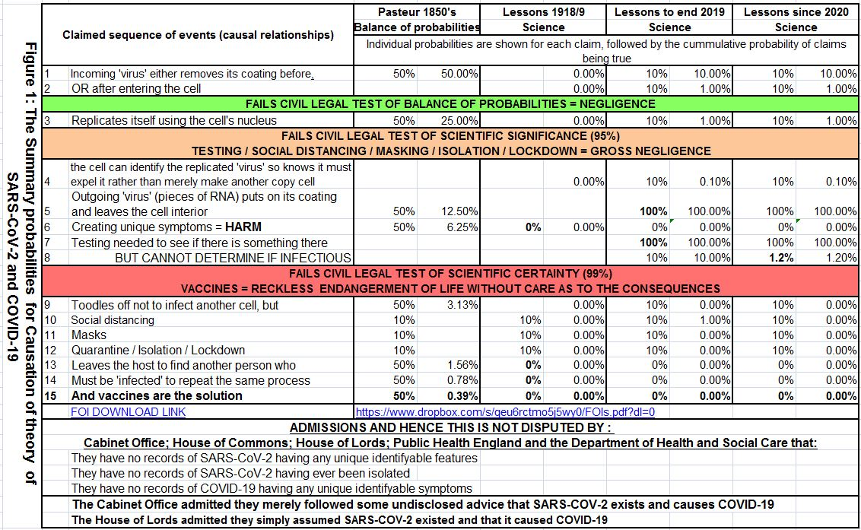

  - Figure 1 shows the summary risk assessment for no unique harm determined as follows (grossly simplified so when you add in more explanations it becomes even less probable!).
    - Precautionary principle = Pasteur's Balance of Probabilities of what was believed at the time: Each only has the equal probability of being true or false = 50%, and cumulative probabilities are shown in square brackets in bold: probability of it being true is 0.39%
    - Lessons learned from the science in 1918/9: probability of it being true is 0%.
    - Lessons learned from science upto end 2019: probability of it being true is 0%.
    - Lessons learned from science since COVID-19: probability of it being true is 0%.
    - By HM Government's own admissions: probability of it being true is 0%.

  - in any event it is admitted that neither (RT)PCR testing, nor Lateral flow testing can determine if there is an infectious agent present;
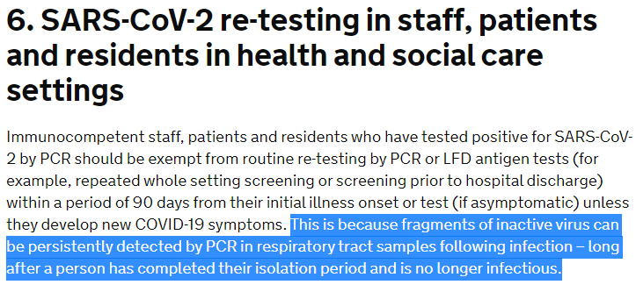
https://www.gov.uk/government/publications/covid-19-management-of-exposed-healthcare-workers-and-patients-in-hospital-settings/covid-19-management-of-exposed-healthcare-workers-and-patients-in-hospital-settings

- THIRDLY, your response is not proportional or reasonable; failing to considering the consequence, and hence impact, of your chosen actions on others, including other creations. This needs to consider the community as a whole, without emotional justification to any special group as all are equal under the law, and no one is above the law as harsh as that may appear.

  - The average age of those 'dying' with COVID-19 is greater than the average life expectancy, and

  - The actual harm to a reasonable person (one who has looked after themselves, by eating well, exercises sufficiently) is admitted, and hence not disputable, is minimal, and, in any event from the OFFICE FOR NATIONAL STATISTICS, COVID-19 deaths by age and deaths from COVID-19 only is below 1%, which is of no statistical significance, and hence is it unlawful for society to bear any burden as the remainder is in large self inflicted harm, and

  - This simple analysis does not even include the many admitted individual, social or economic harms which are again admitted, and hence not disputable.

  - A simple unemotional determination of reasonableness can be objectively done using remaining life years against proportion of COVID-19 related deaths by age groups, which again shows maximum of 11% of deaths might be saved by taking any social action affecting 93.8% of remaining life years, in order to prolong 6.2% of the remaining life years, which is totally unreasonable, illogical as well as irrational and disproportionate!
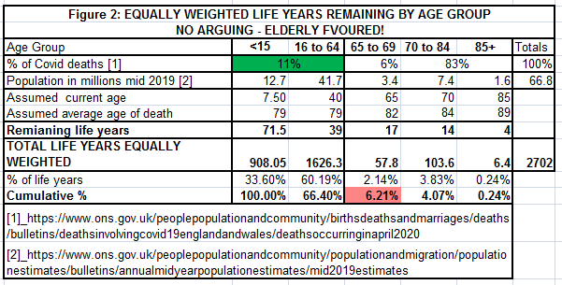

- I SPECIFICALLY ALSO REQUIRE YOUR ANSWERS TO THE FOLLOWING QUESTIONS, supported by peer reviewed science experimentally duplicated by two independent scientists showing:
  - If non pharmaceutical interventions have got rid of the normal coronavirus strains of 'colds and flu', why do they not work against COVID-19?
  - Where are all the bio-hazard waste bins for all these contagious masks?
  - How can they determine that someone has died of COVID-19 when they have suspended autopsies in the UK under emergency measures?
  - SARS-COV-2 causes COVID-19.
  - What is the accuracy of (RT)PCR and Lateral test (without (RT)PCR circular logical fallacy of requiring itself to calibrate itself)
  - How can (RT)PCR and Lateral test determine infectious carriers (asymptomatic).
  - If COVID-19 is so contagious why does it need a swab so deep into the nose. Surely a sterile tissue to blow your nose and cough into are more than enough.
  - What is the percentage reduction in risks of me or you getting infected by:
    - wearing a face covering / mask
    - getting tested
    - isolating
    - lockdown
  - How have they scientifically determined the so-called 'variants' and therefore how can they scientifically prove that the existing vaccines can be effective against these variants?
  - And In regards experimental genetic therapy and or vaccines::
    - By How much does each recommended brand reduce my risks of getting infected?
    - What are the probabilities of each known side affects?
    - Where can I see the published peer reviewed science of your above claims?.

- Further information can be found at http://publicnotices.community/wordpress/wp-content/uploads/2021/03/Schedule-2-COVID-19-evidence-Impossibility-Irrationality-Unreasonableness-20210320.pdf

SCHEDULE 4 - UNDERTAKING AS SETTLEMENT OF DISPUTE

This day day of month in the year 20 21,
I, NOTICE RECEIVER'S name;
Contactable at: NOTICE RECEIVER'S email address;

give this undertaking to, NOTICE SERVER'S name;
Contactable at: NOTICE SERVER'S email address;

- I understand the atrocities of the holocaust in WWII can result from people ‘just following orders', as that was the only solution they saw at the time, to provide for themselves and their families.
- I understand the threats and intimidation many are under, and that fear causes most not to stand up and do what most know and feel in their conscience to be right.
- I have ceased my unlawful actions in respect to enforcing assumed and presumed rights in respect of COVID-19 regulations, and
- I have notified my principles and agents that their continued actions are unlawful, and
- I have notified my principles and agents in future before they enforce any order they are lawfully required to individually ensure before they act upon order that the orders are lawful, and
- I have removed all visible and electronic signage in respect of COVID-19, and
- I undertake to let people make their own informed choices as to how they choose to act until the science is established with scientific certainty, as opposed to merely 'expert opinion, and
- I undertake I will no longer blindly follow order, and will ensure by asking my principles to provide me reasonable evidence what they are asking of me is lawful, and
- I undertake not to implement orders, or gives order until I have first satisfied myself that they are lawful, thereby
- Fulfilling my duty and obligations to my fellow humans, and
- I undertake to no longer turn a blind eye when I have a reasonable belief that others are acting unlawfully.

Signed:

